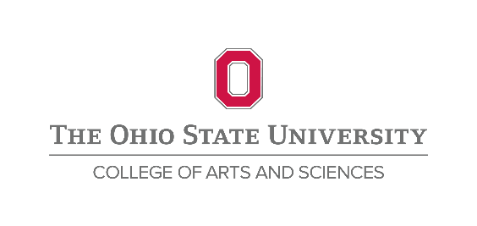

**Department:** Center for Human Resources Research

**Position:** PI of the 1979 National Longitudinal Survey of Youth (NLSY79)

**Rank:** Associate/Full Professor or Research Scientist

**Description:**

The Center for Human Resource Research (CHRR) in the College of Arts and Sciences at The Ohio State University invites applications for the position of Principal Investigator of the 1979 National Longitudinal Survey of Youth (NLSY79). This position may be either as a tenured (associate or full) professor within the College of Social and Behavioral Sciences (SBS), or as a research scientist at CHRR. Candidates should have a strong ongoing record of scholarly research, and should be interested in taking the lead scientific role in shaping the NLSY79. As Principal Investigator (PI) of the NLSY79, the candidate will provide scientific leadership for all aspects of the survey, including questionnaire design and seeking outside funding. Interests in retirement and/or health preferred. Expertise in survey research is desired but not required. The most important qualification for the PI position is willingness to develop and implement a vision for the future of the survey, in collaboration with the Bureau of Labor Statistics as the funding agency, team members at both CHRR and NORC at the University of Chicago, and the user community.



If applying as a faculty member, the successful candidate will be housed in an SBS department in the area of economics, sociology or survey methodology. The individual will be expected to contribute to their department by maintaining a productive research program, teaching and advising PhD students, and providing service to the department and university. The successful candidate's academic tenure home will be in an SBS Department, and the allocation of his or her time and effort between the department and CHRR will be governed by a memorandum of understanding.

If applying as a Research Scientist, the position will be fully funded for the first 3 years. During this time period the candidate will be expected to pursue additional grant opportunities.

**Qualifications:**

The candidate we seek will have an established, active and ongoing record of scholarship at the highest level. He or she will have an international reputation in research. A doctoral degree in a relevant social science discipline is required at the time of application. Appointment is contingent on the university’s verification of credentials and other information required by law and/or university policies, including but not limited to a criminal background check.

**About Columbus:**

The Ohio State University campus is located in Columbus, the capital city of Ohio. Columbus is the center of a rapidly growing and diverse metropolitan area with a population of over 1.5 million. The area offers a wide range of affordable housing, many cultural and recreational opportunities, excellent schools, and a strong economy based on government as well as service, transportation and technology industries(*see* <http://liveworkplaycolumbus.com/>). Columbus has consistently been rated as one of the Top U.S. cities for quality of life, and was selected as one of the Top 10 cities for African Americans to live, work, and play by Black Enterprise magazine. Additional information about the Columbus area is available at [http://www.columbus.](http://www.columbus.org)org.

**Application Instructions:**

Apply to Academic Jobs Online at: <https://academicjobsonline.org/ajo/jobs/8174>. A complete application consists of a cover letter, curriculum vitae, research and teaching statements, a sample of recent publications or working papers and three letters of reference. Applications will be accepted until the position is filled, but those received prior to October 31, 2016 will receive priority consideration. Inquiries may be directed to Professor Elizabeth Cooksey at Cooksey.1@osu.edu.

The Ohio State University is committed to establishing a culturally and intellectually diverse environment, encouraging all members of our learning community to reach their full potential. We are responsive to dual-career families and strongly promote work-life balance to support our community members through a suite of institutionalized policies. We are an [NSF Advance Institution](https://email.osu.edu/owa/redir.aspx?C=pq8lyvcHsU-B0ymOrhYcY7tqTwjCv9EI_vMqMP6O-NVypEBPt4D3nYfHLsU32N6oCqwlZO2GFIk.&URL=http%3a%2f%2fstemm.osu.edu%2f) and a member of the [Ohio/Western Pennsylvania/West Virginia Higher Education Recruitment Consortium](https://email.osu.edu/owa/redir.aspx?C=pq8lyvcHsU-B0ymOrhYcY7tqTwjCv9EI_vMqMP6O-NVypEBPt4D3nYfHLsU32N6oCqwlZO2GFIk.&URL=http%3a%2f%2fwww.hercjobs.org%2foh-western-pa-wv%2f) (HERC).

*The Ohio State University is an equal opportunity employer. All qualified applicants will receive consideration for employment without regard to race, color, religion, sex, sexual orientation or identity, national origin, disability status, or protected veteran status.*